EXPERIMENTS

NAME:BHARANI DHARAN S
REG NO:192424141
COURSE CODE:DSA0602 DATA HANDLING AND VISUALIZATION

SET 2 – WEBSITE ANALYTICS

Date | Page Views | Click-through Rate
2023-01-01 | 1500 | 2.3%
2023-01-02 | 1600 | 2.7%
2023-01-03 | 1400 | 2.0%
2023-01-04 | 1650 | 2.4%
2023-01-05 | 1800 | 2.6%

QUESTION 1
Create a line chart to visualize the trend in daily page views over time. Label the axes and title the chart.

AIM
To create a line chart to visualize the trend of daily website page views over time.

PROCEDURE
- Create the website traffic dataset.
- Store the date and page views.
- Convert the date into Date format.
- Use the plot() function to create a line chart.
- Label the X-axis and Y-axis.
- Add a suitable title.

CODE

date <- as.Date(c("2023-01-01", "2023-01-02", "2023-01-03", "2023-01-04", "2023-01-05"))

page_views <- c(1500, 1600, 1400, 1650, 1800)

plot(
date,
page_views,
type = "o",
xlab = "Date",
ylab = "Page Views",
main = "Daily Website Page Views"
)OUTPUT

RESULT
Thus, the line chart was successfully created to visualize the daily trend in website page views.

QUESTION 2
Generate a bar chart showing the top N days with the highest click-through rates. Label the chart elements.

AIM
To create a bar chart showing the days with the highest click-through rates.

PROCEDURE
- Create the date and click-through-rate data.
- Store the values in a data frame.
- Sort the click-through rates in descending order.
- Select the top N days.
- Create a bar chart using barplot().
- Add labels and title.

CODE
date <- c("2023-01-01", "2023-01-02", "2023-01-03", "2023-01-04", "2023-01-05")

ctr <- c(2.3, 2.7, 2.0, 2.4, 2.6)

website <- data.frame(
Date = date,
CTR = ctr
)

website <- website[order(-website$CTR), ]

top_n <- website[1:3, ]

barplot(
top_n$CTR,
names.arg = top_n$Date,
xlab = "Date",
ylab = "Click-through Rate (%)",
main = "Top 3 Days with Highest Click-through Rate",
ylim = c(0, 3)
)

OUTPUT

RESULT
Thus, the bar chart was successfully created to display the top 3 days with the highest click-through rates.

QUESTION 3

Develop a stacked area chart to display the distribution of user interactions (likes, shares, comments) on a website.

AIM
To create a stacked area chart showing the distribution of likes, shares, and comments over time.

PROCEDURE
- Create the date data.
- Enter likes, shares, and comments.
- Create a data frame.
- Use the stack() function to organize the interaction data.
- Use matplot() to create the stacked area chart.
- Add labels, title, and legend.

CODE
date <- as.Date(c("2023-01-01", "2023-01-02", "2023-01-03", "2023-01-04", "2023-01-05"))

likes <- c(120, 150, 100, 170, 200)
shares <- c(40, 55, 35, 60, 75)
comments <- c(20, 25, 18, 30, 35)

interactions <- cbind(likes, shares, comments)

cumulative <- apply(interactions, 1, cumsum)

plot(
date,
cumulative[1, ],
type = "n",
ylim = c(0, max(cumulative)),
xlab = "Date",
ylab = "Number of Interactions",
main = "Website User Interactions"
)

polygon(
c(date, rev(date)),
c(rep(0, length(date)), rev(cumulative[1, ])),
border = NA
)

polygon(
c(date, rev(date)),
c(cumulative[1, ], rev(cumulative[2, ])),
border = NA
)

polygon(
c(date, rev(date)),
c(cumulative[2, ], rev(cumulative[3, ])),
border = NA
)

legend(
"topleft",
legend = c("Likes", "Shares", "Comments"),
fill = c("grey80", "grey60", "grey40")
)OUTPUT

RESULT
Thus, a stacked area chart was successfully created to visualize the distribution of website user interactions.

QUESTION 4

Build a Tableau dashboard with the line chart and bar chart for interactive exploration of website traffic data.

AIM
To develop an interactive website traffic dashboard using R Shiny with a line chart and bar chart.

PROCEDURE
- Install and load the shiny and ggplot2 packages.
- Create the website traffic dataset.
- Create a user interface with a date selection.
- Create a line chart for page views.
- Create a bar chart for click-through rates.
- Display both charts in the dashboard.
- Allow the user to select dates interactively.
- Run the Shiny application.

CODE
library(shiny)
library(ggplot2)

website <- data.frame(
Date = as.Date(c(
"2023-01-01",
"2023-01-02",
"2023-01-03",
"2023-01-04",
"2023-01-05"
)),
Page_Views = c(1500, 1600, 1400, 1650, 1800),
CTR = c(2.3, 2.7, 2.0, 2.4, 2.6)
)

ui <- fluidPage(
titlePanel("Website Traffic Dashboard"),

sidebarLayout(
sidebarPanel(
dateRangeInput(
"date",
"Select Date Range",
start = min(website$Date),
end = max(website$Date)
)
),

mainPanel(
plotOutput("lineChart"),
plotOutput("barChart")
)
)
)

server <- function(input, output) {

filtered_data <- reactive({
website[
website$Date >= input$date[1] &
website$Date <= input$date[2],
]
})

output$lineChart <- renderPlot({
ggplot(
filtered_data(),
aes(x = Date, y = Page_Views)
) +
geom_line() +
geom_point() +
labs(
title = "Daily Page Views",
x = "Date",
y = "Page Views"
)
})

output$barChart <- renderPlot({
ggplot(
filtered_data(),
aes(x = Date, y = CTR)
) +
geom_bar(stat = "identity") +
labs(
title = "Click-through Rate",
x = "Date",
y = "Click-through Rate (%)"
)
})
}

shinyApp(ui = ui, server = server)

OUTPUT
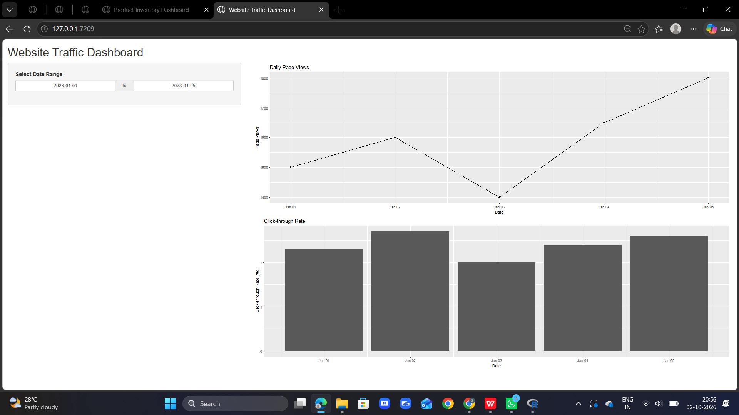

RESULT
Thus, an interactive Website Traffic Dashboard was successfully developed using R Shiny with a line chart and bar chart for exploring website traffic data.

